**Broadcasting Using a Scalar Value**

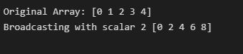

**Demeaning Column Using Broadcasting**

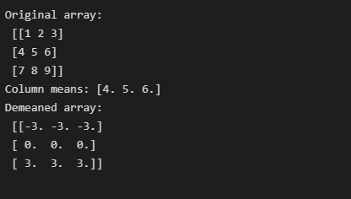

**Demeaning Rows & Reshaping to Broadcast**

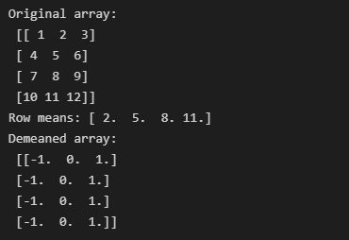

**Broadcasting over other Axis**

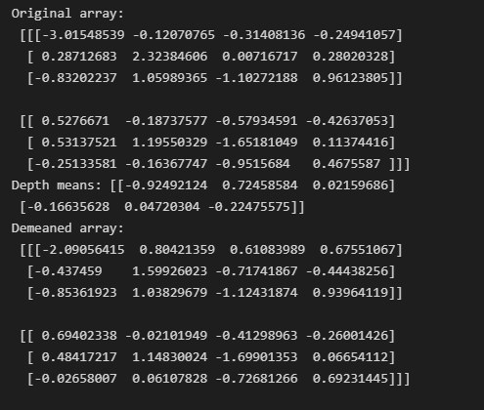

**Setting Values Using Broadcasting**

